CMP 409 DR Adelaiye AI

# Artificial intelligence

Applications of AI

* Self-driving cars

What is intelligence -: ability to use facts, data, experience to solve problems. It is how you use your exposure to solve problems. It is also the ability to apply knowledge to manipulate one’s environment to think abstractly as measured by objective criteria

Methods of gaining experience

* Observation

What is AI?

Systems that think and act rationally like humans

Haugeland 1985, bellman 1978

## Turing test

Designed in 1950 by Alan Turing, a Turing test is a test performed to determine a machines ability to exhibit intelligence behaviour. it measures the machines’ ability to think and act like a human and if it is quantified as so, it is said to have passed the test.

# Understanding Natural Language

This is the way we communicate with each other usually through linguistics.

Deep Exploration and filtering the text

It is the comprehension by computers of the structure and the meaning of the human language. it is the process where the machine can take and transform unstructured data to structured data.

NLU vs NLP understanding vs processing

NLU is a subset of NLP which is all under NLE

NLU interprets the meaning and classifies the intent. It is responsible for distinguishing intent through methods such as text classification, content analysis, sentiment analysis

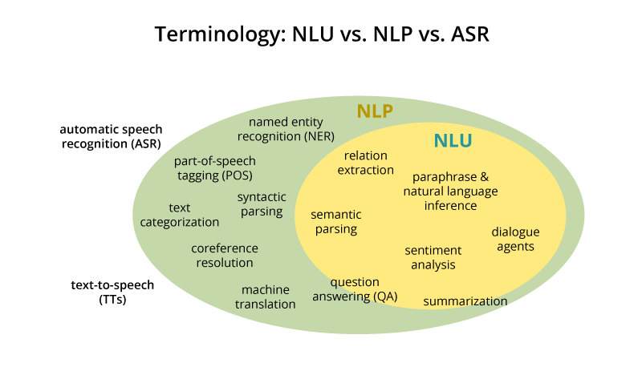

## History

* 1950: origin
* 70-80: coding
* 1990-2015: statistical revolution (machine learning )

AI is majorly dependent on statistics.

# Natural language processing

For a machine to be able to process a language, it has to first understand it. Sanitization of data is a work on its own. London NLP is a subfield of AI

Libraries like: spaCy, textacy, neuralcoref

Steps of an ai

1. Segmentation
2. Tokenization
3. Speech analysis: tokens are broken down to their parts of speech
4. Text lemmatization: deals with figuring out the most basic lemma of each word in a sentence
5. Dealing with stop words
6. Dependency parsing: this checks if the words are independent or not
7. Named entity recognition
8. Co-reference resolution: referencing nouns to be identified as subsequent pronouns.

Token is the smallest form of anything that still makes sense. while humans learn from experiences, machines learn from

Stop words: this are words that appear often in a sentence to make it more presentable.

Data scrubber

# 27th November 2024

Knowledge is defined as

How will a machine use information and convert it to knowledge?

Knowledge representation: is to express knowledge in a computer tractable form

* Syntax: configurations of the components of the language to constitute valid sentences.
* Semantics: what fact does the sentence correspond to?

Properties of knowledge

* Representational adequacy: all knowledge needed for the domain
* Inferential adequacy : ability to manipulate existing structures to derive new structures. Create something new from something that already exists.
* Inferential efficiency: the new thing… how does it fit to what exists
* Acquisitioned efficiency: ability to acquire new knowledge

Good Representation

The information you want to use or train a system, the system must be able to understand it

The information must be relevant do not distract the system with noise

Constraints allowance

Transparent, concise and fast

Components

1. Lexical part symbols that are used to represent a
2. Syntax part
3. Sematic part
4. Procedural: tells how things are done

Advantages of natural language

* Extremely expressive:

Disadvantage

1. Not fully understood
2. Ambiguous
3. Little uniformity

Database systems: a structured format of data representation. After definition, the system can interact with the information. It consists of a number of records stored in asci format

Advantages

* Efficient representation and processing of large amounts of data

Disadvantages

* Limited to domain context
* Only entities and their relationships can be represented

**Normalization of databases**

Frame based systems: records that have been extended to become frames consisting to slots filled with either values, procedures, or pointers

Semantics networks:

First order logic

**∀ for all**

**∃ there exists**

**∄ there does not exist**

Advantages: expressive and unambiguous

Rule based systems: consists of a management system, a rule for representing he relations and a rule interpreter for problem solving. Simplified, it is giving conditions to the program i.e. **if** this, **then** do this. **Else**, do this

Advantages: expressive and lead to a degree of modularity

Disadvantages: very limited and inefficient

Best knowledge representation

* Symbolic
* Pictorial

Sub-symbolic

EXPERT SYSTEMS

An expert is a person with a vast knowledge or ability based on research, experience, or occupation in a particular area. Expert systems solve complex problems in a particular domain at the level of extra ordinary human intelligence and expertise. To build an expert system, you need:

1. Domain expert: the person who applies the field the most
2. Knowledge engineer: the developer
3. Knowledge user: the people who use the system the most

Characteristics

* High performance
* Understandable
* Reliable
* Highly responsive

Capabilities

1. Advising
2. Instructing
3. Demonstrating
4. Deriving etc.

Components

* Knowledge base
* Inference engine: decision making based on existing knowledge
* User interface

Component of knowledge base

* Factual
* Heuristic

***The Last***

Create a model and an interface

Write a report including introduction, background, what you are working on an

It is a presentation and individual marks are gotten by how you present

We will be meeting virtually and on resumption we will be doing presentation